

CS-110: Lab 10
Two-Dimensional Arrays

https://github.com/mmujtaba25/CS-110

Muhammad Mujtaba
CMD ID: 540040
mmujtaba.bese25seecs@seecs.edu.pk

  - Class: BESE 16B
  - Batch: 2k25

Task 1: [CLO1]

CODE:
#include <iostream>
#include <iomanip>

int numDigits(int number);

// templates prototypes works, because definations are given later

template <size_t M, size_t N>
void printMatrix(int matrix[M][N], int spacing = 0);

template <size_t M, size_t N, size_t P, size_t Q>
void multiplyMatrix(int mat1[M][N], int mat2[P][Q], int result[M][Q]);

template <size_t
M, size_t N>
void readMatrix(int matrix[M][N]);

int main()
{
constexpr int M = 3;
constexpr int N = 3;
constexpr int P = 3;
constexpr int Q = 3;

int mat1[M][N], mat2[P][Q];
int prod[M][Q]; // for MxN * PxQ order is MxQ

// init mat1
std::cout << "Enter Matrix 1 (" << M << "x" << N << "):\n";
readMatrix<M, N>(mat1);

// init mat2
std::cout << "Enter Matrix 2 (" << P << "x" << Q << "):\n";
readMatrix<P, Q>(mat2);

// init prod -> 0
for (int i = 0; i < M; i++)
{
for (int j = 0; j < Q; j++)
{
prod[i][j] = 0;
}
}

multiplyMatrix<M, N, P, Q>(mat1, mat2, prod);

// print mat1 matrix
std::cout << "\n\nMatrix 1\n";
printMatrix<M, N>(mat1);

// print mat2 matrix
std::cout << "\n\nMatrix 2\n";
printMatrix<P, Q>(mat2);

// print sum matrix
std::cout << "\n\nProduct\n";
printMatrix<M, Q>(prod);

return 0;
}

int numDigits(int number)
{
int digits = 0;
bool negative = number < 0;
number = std::abs(number); // ignore -ive sign

// number between 0 and 10
if (number > 0 && number < 10)
{
digits = 1;
goto return_digit;
}

// this is false when number is less then 0
while (number > 0)
{
number /= 10;
digits++;
}

return_digit:
return digits + (negative ? 1 : 0); // add one is digit is negative
}

template <size_t M, size_t N>
void printMatrix(int matrix[M][N], int spacing)
{
constexpr int padding = 2;
int max_spacing = 1;
// calculate spacing
for (size_t i = 0; i < M; i++)
{
for (size_t j = 0; j < N; j++)
{
max_spacing = std::max(numDigits(matrix[i][j]) + padding, max_spacing);
}
}

// use user given option if possible
max_spacing = std::max(max_spacing, spacing);

for (size_t i = 0; i < M; i++)
{
std::cout << "|";
for (size_t j = 0; j < N; j++)
{
std::cout << std::right << std::setw(max_spacing) << matrix[i][j];
}
std::cout << " |\n";
}
}

template <size_t M, size_t N, size_t P, size_t Q>
void multiplyMatrix(int mat1[M][N], int mat2[P][Q], int result[M][Q])
{
// loop over all elements in first row of mat1
// loop over all elements in first column of mat2
// multiply each element and sum[i][j] = sum

if (N != P)
{
std::cout << "* Please use a valid index.";

for (size_t i = 0; i < M; i++)
{
for (size_t j = 0; j < Q; j++)
{
// set all to -1 in case of error
result[i][j] = -1;
}
}
return;
}

for (size_t i = 0; i < M; i++)
{
for (size_t j = 0; j < Q; j++)
{
int sum = 0;

// sum[i][j] = summation(mat1[i][k] * mat2[k][j])
// k goes from (0 -> N) where N in MxN * PxQ, note that P is same as N in this scenario
for (size_t k = 0; k < N; k++)
{
sum += mat1[i][k] * mat2[k][j];
}

result[i][j] = sum;
}
}
}

template <size_t M, size_t N>
void readMatrix(int matrix[M][N])
{
for (size_t i = 0; i < M; i++)
{
for (size_t j = 0; j < N; j++)
{
int value;

while (true)
{
std::cout << "Enter value for [" << i << "][" << j << "]: ";

if (std::cin >> value)
break; // valid integer

// invalid input
std::cout << "* Invalid input. Please enter an integer.\n";

// silently discard invalid input
std::cin.clear();
std::cin.ignore(std::numeric_limits<std::streamsize>::max(), '\n');
}

matrix[i][j] = value;
}
}
}

OUTPUT:
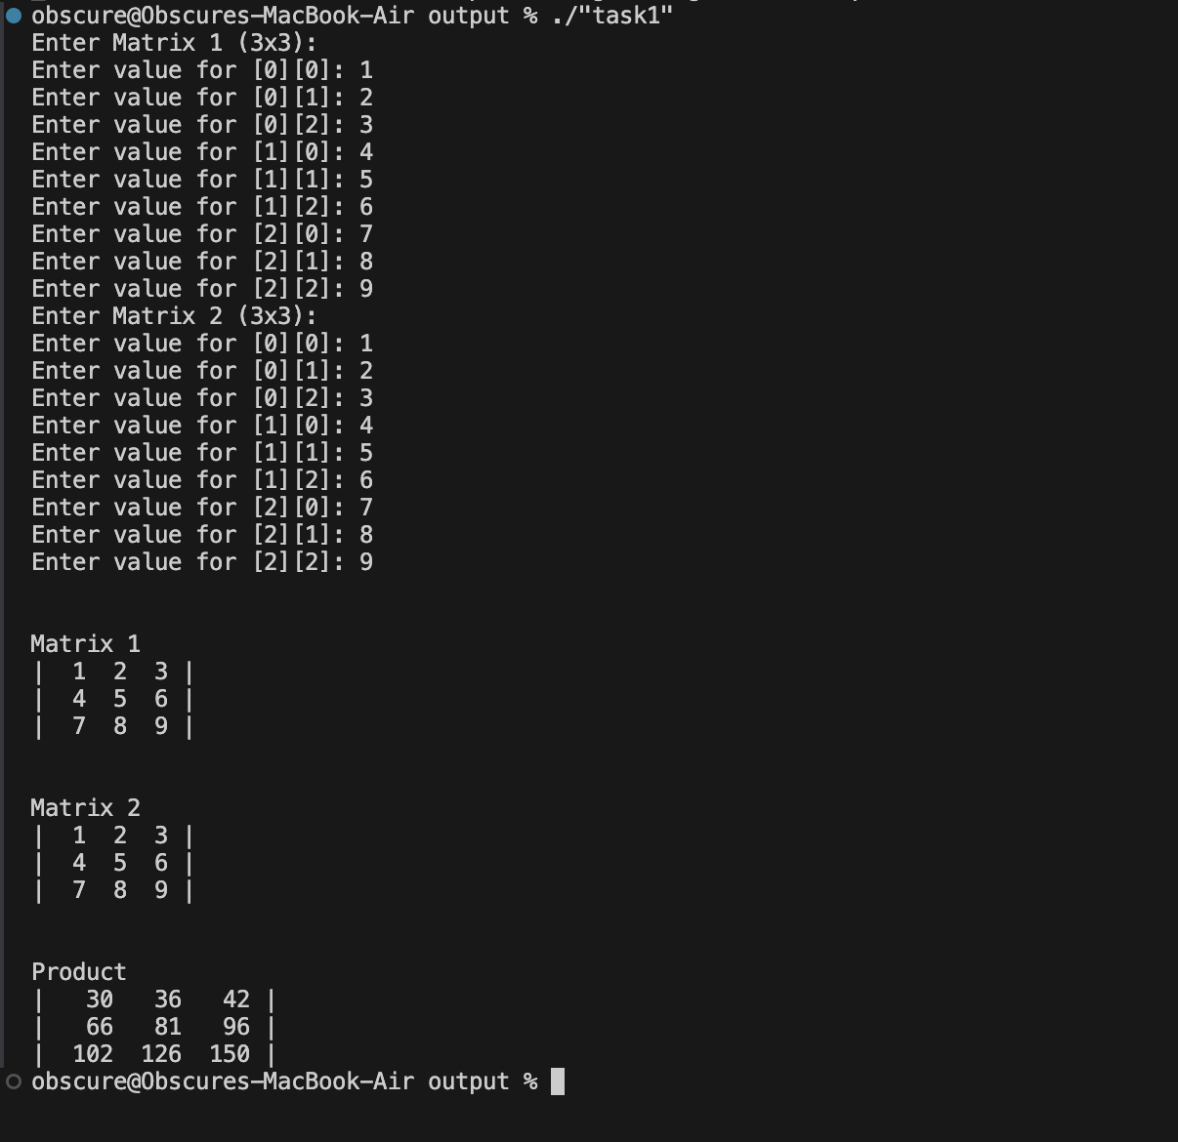

Task 2: [CLO 2]

CODE:
#include <iostream>
#include <iomanip>
#include <cstdlib>
#include <ctime>

int numDigits(int number);
template <size_t M, size_t N>
void printMatrix(int matrix[M][N], int spacing = 0);

int main()
{
constexpr int M = 6;
constexpr int N = 6;

int mat1[M][N];
int mat1_b[M][N];

unsigned int seed;
std::cout << "Enter Seed (-1 for random): ";
std::cin >> seed;

seed = (seed == -1u ? time(0) : seed);

int thresholdValue = 0;
int sum_elements = 0;

// init mat1
srand(seed);
for (int i = 0; i < M; i++)
{
for (int j = 0; j < N; j++)
{
mat1[i][j] = rand() % 255;
sum_elements += mat1[i][j];
}
}

// clamp to 255
thresholdValue = sum_elements / M * N;
thresholdValue %= 255;

for (int i = 0; i < M; i++)
{
for (int j = 0; j < N; j++)
{
if (mat1[i][j] > thresholdValue)
mat1_b[i][j] = 1;
else
mat1_b[i][j] = 0;
}
}

std::cout << "\n\nMatrix 1\n";
printMatrix<M, N>(mat1);

std::cout << "\n\nBinarized Matrix 1\n";
printMatrix<M, N>(mat1_b);

return 0;
}

int numDigits(int number)
{
int digits = 0;
bool negative = number < 0;
number = std::abs(number); // ignore -ive sign

// number between 0 and 10
if (number > 0 && number < 10)
{
digits = 1;
goto return_digit;
}

// this is false when number is less then 0
while (number > 0)
{
number /= 10;
digits++;
}

return_digit:
return digits + (negative ? 1 : 0); // add one is digit is negative
}

template <size_t M, size_t N>
void printMatrix(int matrix[M][N], int spacing)
{
constexpr int padding = 2;
int max_spacing = 1;
// calculate spacing
for (size_t i = 0; i < M; i++)
{
for (size_t j = 0; j < N; j++)
{
max_spacing = std::max(numDigits(matrix[i][j]) + padding, max_spacing);
}
}

// use user given option if possible
max_spacing = std::max(max_spacing, spacing);

for (size_t i = 0; i < M; i++)
{
std::cout << "|";
for (size_t j = 0; j < N; j++)
{
std::cout << std::right << std::setw(max_spacing) << matrix[i][j];
}
std::cout << " |\n";
}
}

OUTPUT:
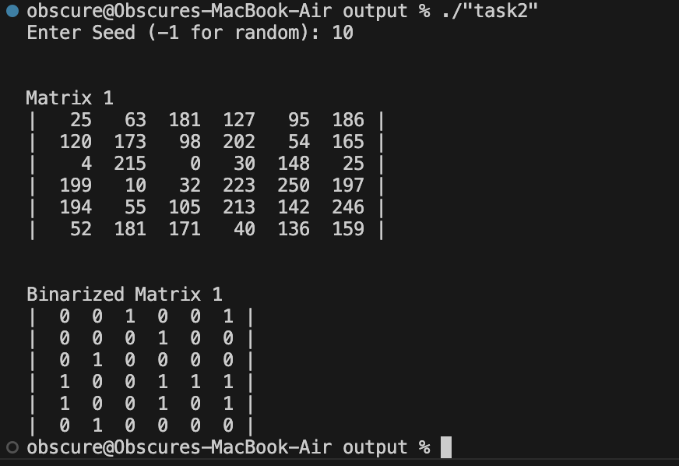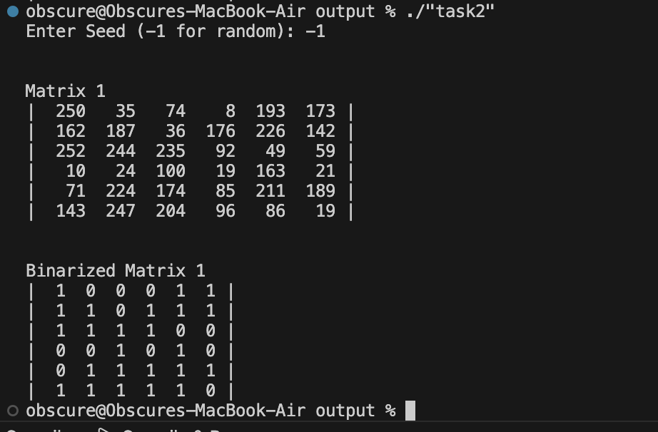

Task 3: [CLO 3]

CODE:
#include <iostream>
#include <iomanip>
int numDigits(int number);
template <size_t M, size_t N>
void printMatrix(int matrix[M][N], int spacing = 0);
template <size_t M, size_t N>
void readMatrix(int matrix[M][N]);
int main()
{
constexpr int N = 5;
int adjacency[N][N];

std::cout << "Enter adjacency matrix (" << N << "x" << N << "):\n";
readMatrix<N, N>(adjacency);

int inDegrees[N] = {0};
int outDegrees[N] = {0};

// compute degrees
for (size_t i = 0; i < N; i++)
{
for (size_t j = 0; j < N; j++)
{
outDegrees[i] += adjacency[i][j]; // sum of row = out-degree
inDegrees[j] += adjacency[i][j]; // sum of column = in-degree
}
}

std::cout << "\nAdjacency Matrix:\n";
printMatrix<N, N>(adjacency);

for (size_t i = 0; i < N; i++)
{
std::cout << "Node #" << i << ": out-degree = " << outDegrees[i]
<< ", in-degree = " << inDegrees[i] << "\n";
}

return 0;
}

int numDigits(int number)
{
int digits = 0;
bool negative = number < 0;
number = std::abs(number);

if (number > 0 && number < 10)
{
digits = 1;
goto return_digit;
}

while (number > 0)
{
number /= 10;
digits++;
}

return_digit:
return digits + (negative ? 1 : 0);
}

template <size_t M, size_t N>
void printMatrix(int matrix[M][N], int spacing)
{
constexpr int padding = 2;
int max_spacing = 1;

for (size_t i = 0; i < M; i++)
{
for (size_t j = 0; j < N; j++)
{
max_spacing = std::max(numDigits(matrix[i][j]) + padding, max_spacing);
}
}

max_spacing = std::max(max_spacing, spacing);

for (size_t i = 0; i < M; i++)
{
std::cout << "|";
for (size_t j = 0; j < N; j++)
{
std::cout << std::right << std::setw(max_spacing) << matrix[i][j];
}
std::cout << " |\n";
}
}

template <size_t M, size_t N>
void readMatrix(int matrix[M][N])
{
for (size_t i = 0; i < M; i++)
{
for (size_t j = 0; j < N; j++)
{
int value;
while (true)
{
std::cout << "Enter value for [" << i << "][" << j << "]: ";
if (std::cin >> value)
break;

std::cout << "* Invalid input. Please enter an integer.\n";
std::cin.clear();
std::cin.ignore(std::numeric_limits<std::streamsize>::max(), '\n');
}
matrix[i][j] = value;
}
}
}

template <size_t M, size_t N>
void printMatrix(int matrix[M][N], int spacing)
{
constexpr int padding = 2;
int max_spacing = 1;

for (size_t i = 0; i < M; i++)
{
for (size_t j = 0; j < N; j++)
{
max_spacing = std::max(numDigits(matrix[i][j]) + padding, max_spacing);
}
}

max_spacing = std::max(max_spacing, spacing);

for (size_t i = 0; i < M; i++)
{
std::cout << "|";
for (size_t j = 0; j < N; j++)
{
std::cout << std::right << std::setw(max_spacing) << matrix[i][j];
}
std::cout << " |\n";
}
}

template <size_t M, size_t N>
void readMatrix(int matrix[M][N])
{
for (size_t i = 0; i < M; i++)
{
for (size_t j = 0; j < N; j++)
{
int value;
while (true)
{
std::cout << "Enter value for [" << i << "][" << j << "]: ";
if (std::cin >> value)
break;

std::cout << "* Invalid input. Please enter an integer.\n";
std::cin.clear();
std::cin.ignore(std::numeric_limits<std::streamsize>::max(), '\n');
}
matrix[i][j] = value;
}
}
}

OUTPUT:
